EE3011.ELECTRONICS 1

Experiment (6)
Mosfet IV Characteristics

(Section A)

Mehmet Akif Türkmenoğlu
150720061

Part (1): MOSFET IV Characteristics

For the first part, I connected to circuit as it is and give the values of 1Mega Ohm to R1 and R2, 1k to RD and +8V to VGG. Then I change the voltage of VDD as starting from 0 to 10V.
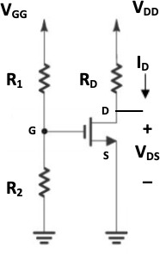

This is the circuit that I have.

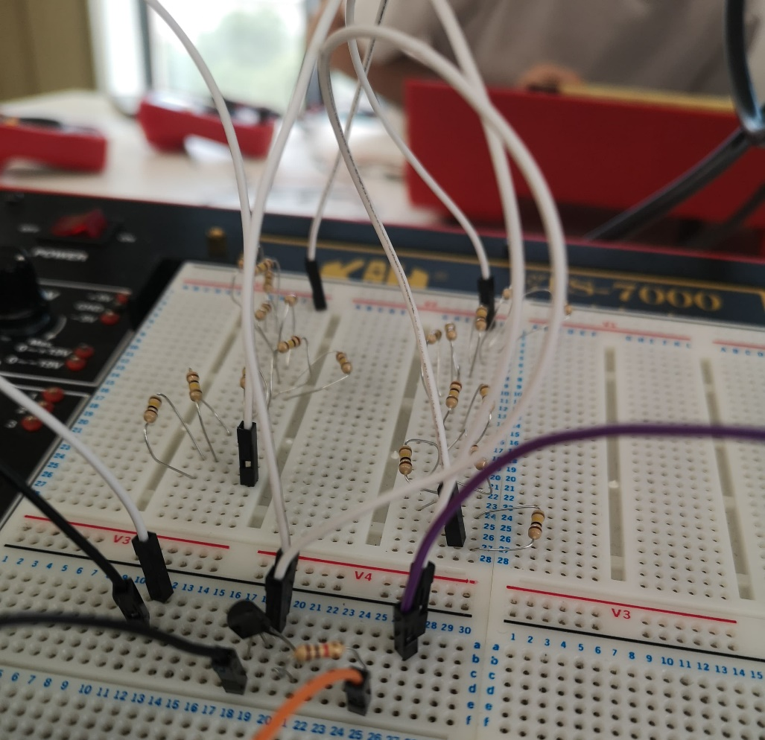

Because there is no 1 MegaΩ resistor I connected 10 10kΩ resistors to get 1 MegaΩ. We use this much resistor to ignore the value. Then I record the voltage and current values and merge them in table 2 and graph 1.
Table 2. IV Characteristics Measurements
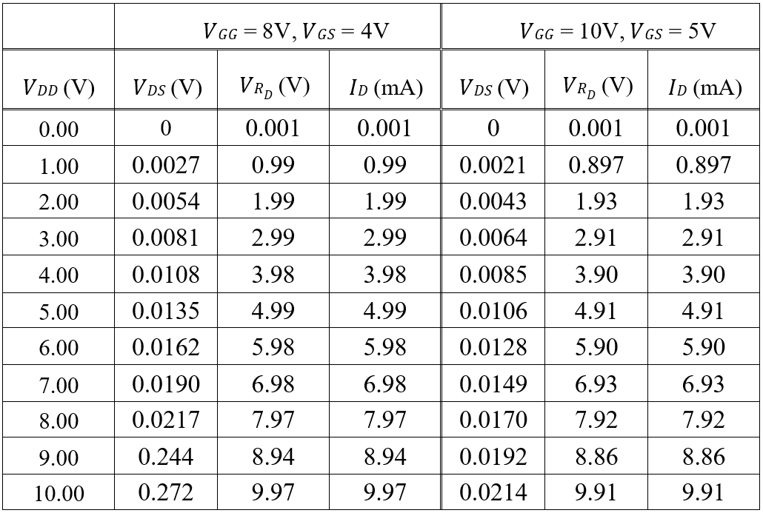

Graph 1. Mosfet IV Curves

Graph 1. Mosfet IV Curves
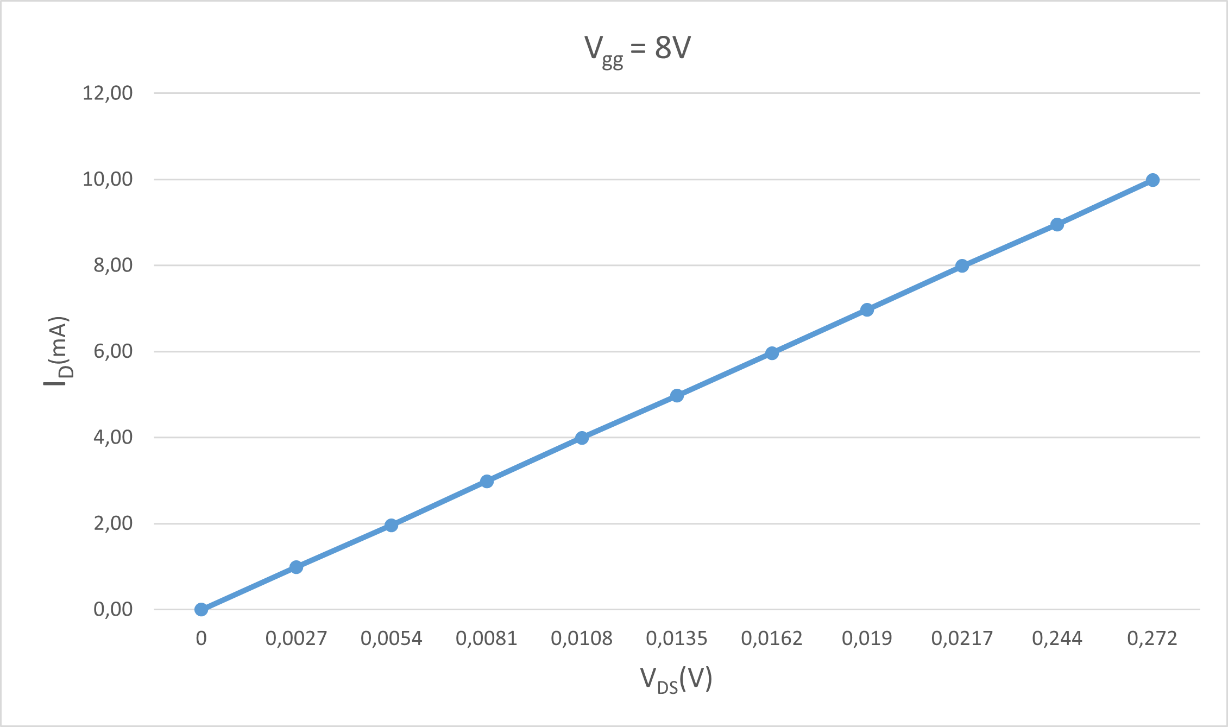

- Comment on the IV curves that you obtained. Can you identify the transistor modes of operation?
Answer: The mosfet is in saturation mode and the IV curve is linearly increasing.

- Is the drain current constant in the saturation region of the IV curve? Explain why or why not.
Answer: Drain current is not constant it changes according to r0.

Part (2): Graphical Analysis of a DC MOSFET Circuit.

We asked to draw the load line on top of the IV curves in graph 1. I marked the intersection point of the curves.

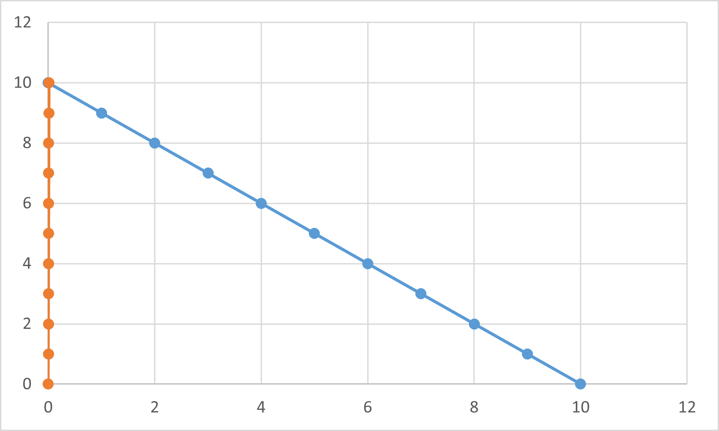

The experimental value of 𝐼_{𝐷} = (𝑉_{𝐷𝐷} − 𝑉_{𝐷𝑆})/𝑅_{𝐷}.
Then I record the results in table 3.

Table 3. Graphical Solution Results.
𝑉_{𝐷𝐷}= 10 V and 𝑉_{𝐺𝐺} = 10 V
𝑉_{𝐷𝑆} (V) Experimental value | 𝑉_{𝐷𝑆} (V) Graphical value | %  Difference | 𝐼_{𝐷} (mA) Experimental value | 𝐼_{𝐷} (mA) Graphical value | %  Difference
0,024 | 0,026 | 7,6923 | 10,01 | 9,97 | 0,4011

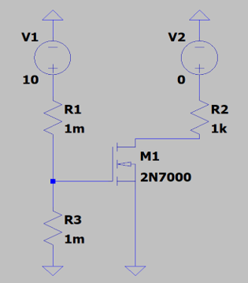
If we increase the voltage value more slowly, the error decreases.
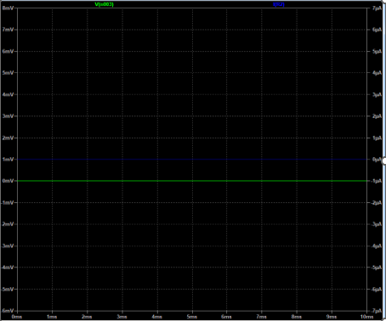

𝑉_{𝐷𝐷}= 0 V and 𝑉_{𝐺𝐺} = 10 V

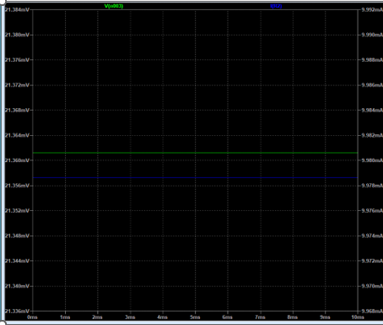
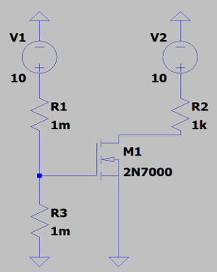

𝑉_{𝐷𝐷}= 10 V and 𝑉_{𝐺𝐺} = 10 V
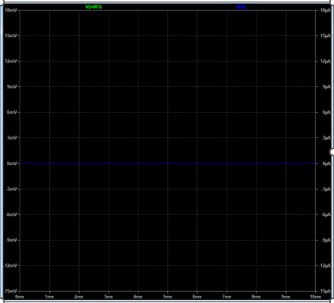
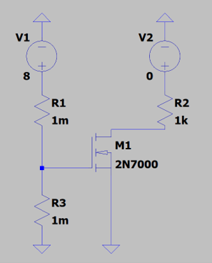

𝑉_{𝐷𝐷}= 0 V and 𝑉_{𝐺𝐺} = 8 V
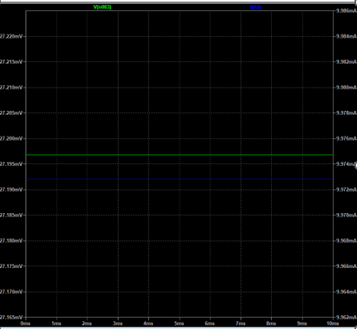
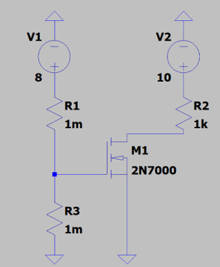
v

𝑉_{𝐷𝐷}= 10 V and 𝑉_{𝐺𝐺} = 8 V
These are the Ltspice simulations. I don’t need to put all the experimental values. I am sure of my measurements and calculations. I hope it is correct.

